# **Bar-Chart**

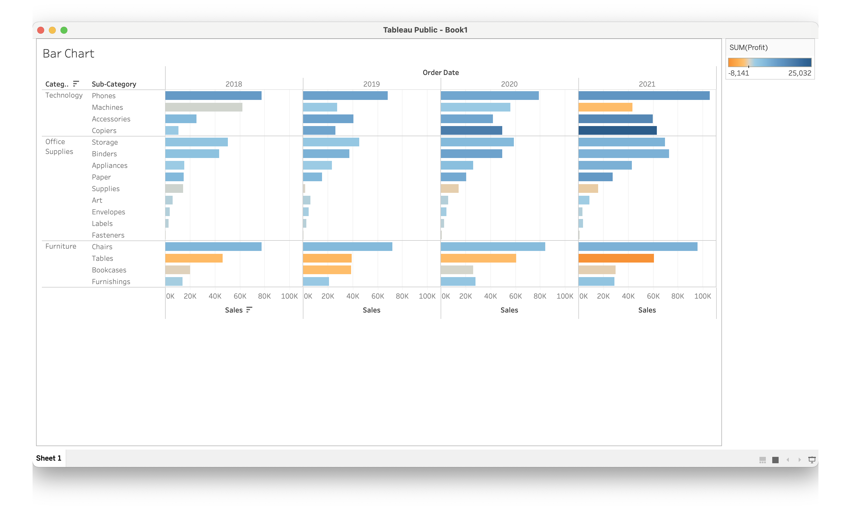

Among all the sub-category,   
Phones sales is the huge ir-respective to the profit.  
Table’s profit is low and the sales is just boosting up in the year 2020 and 2021.

# **On applying the filters**

Furniture field

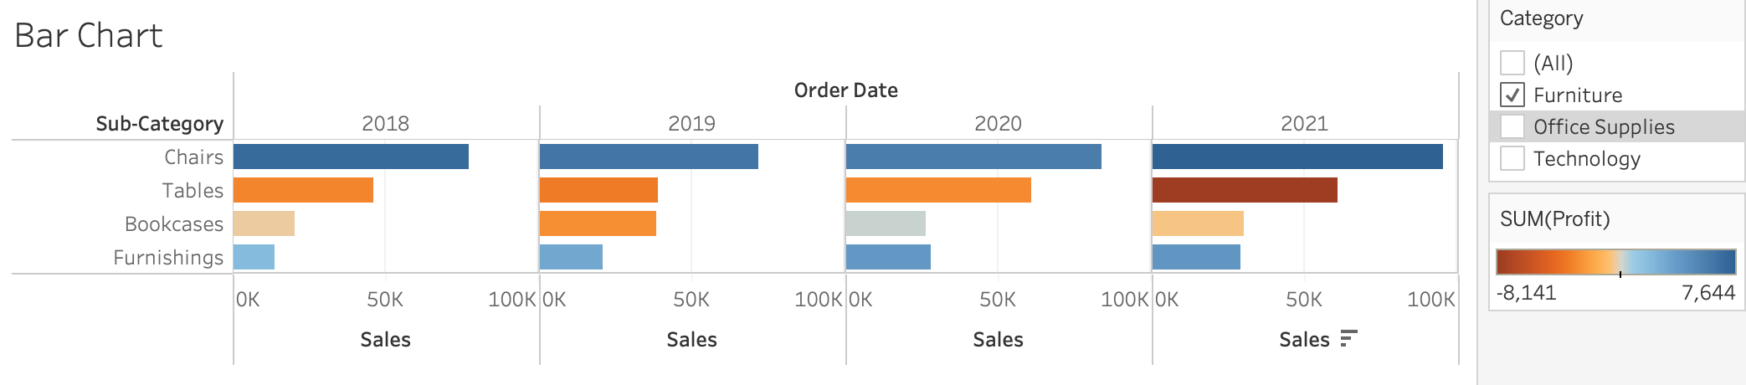

Office Supplies field

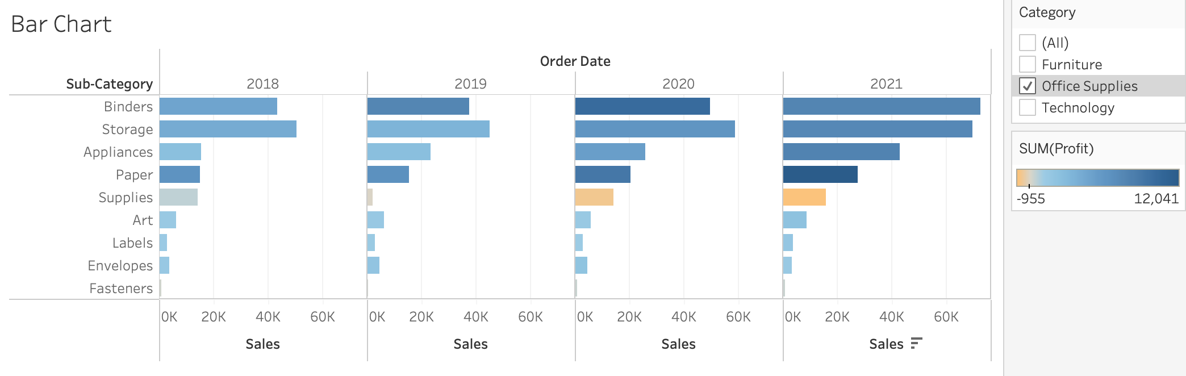

Technology field

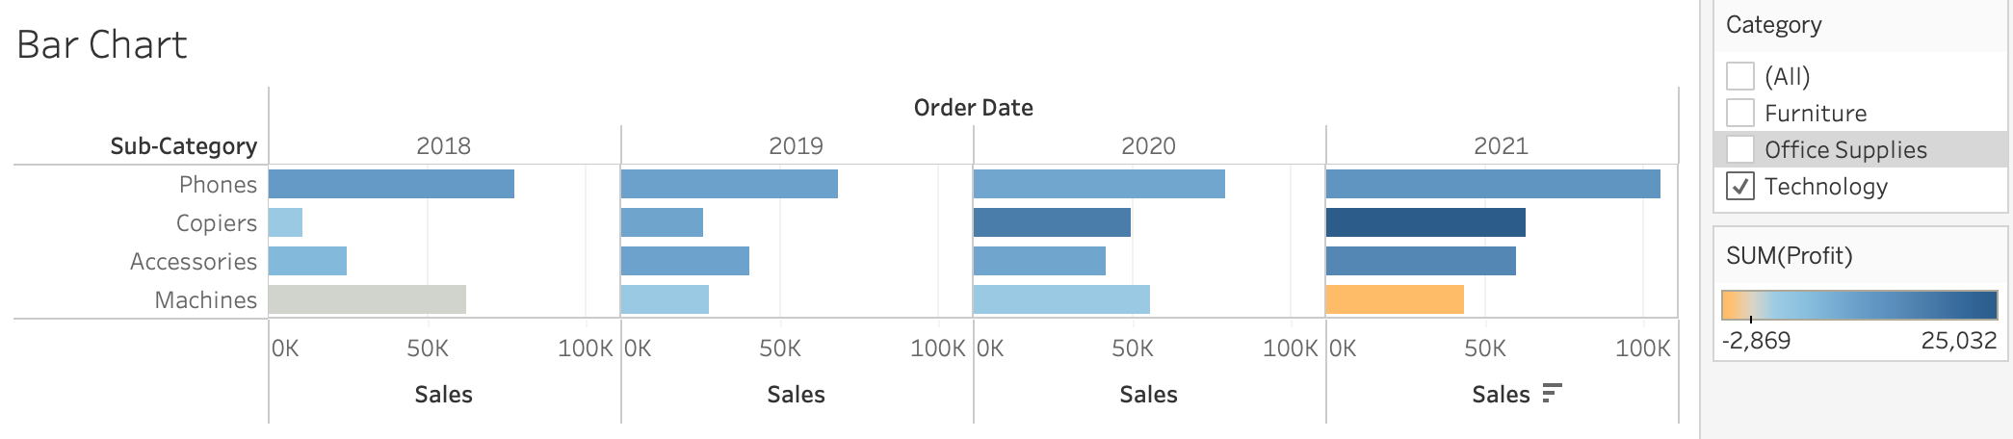

# **Analysing Phones and Copiers**

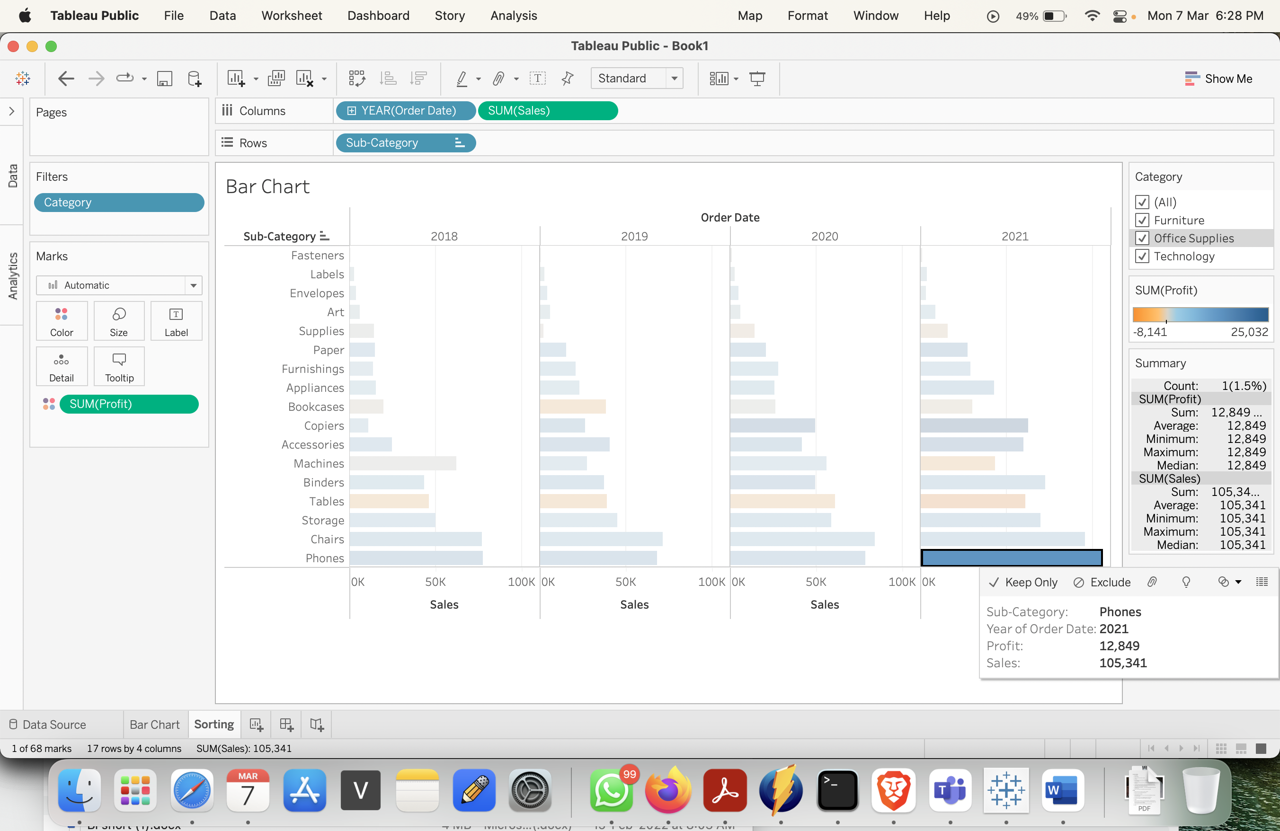

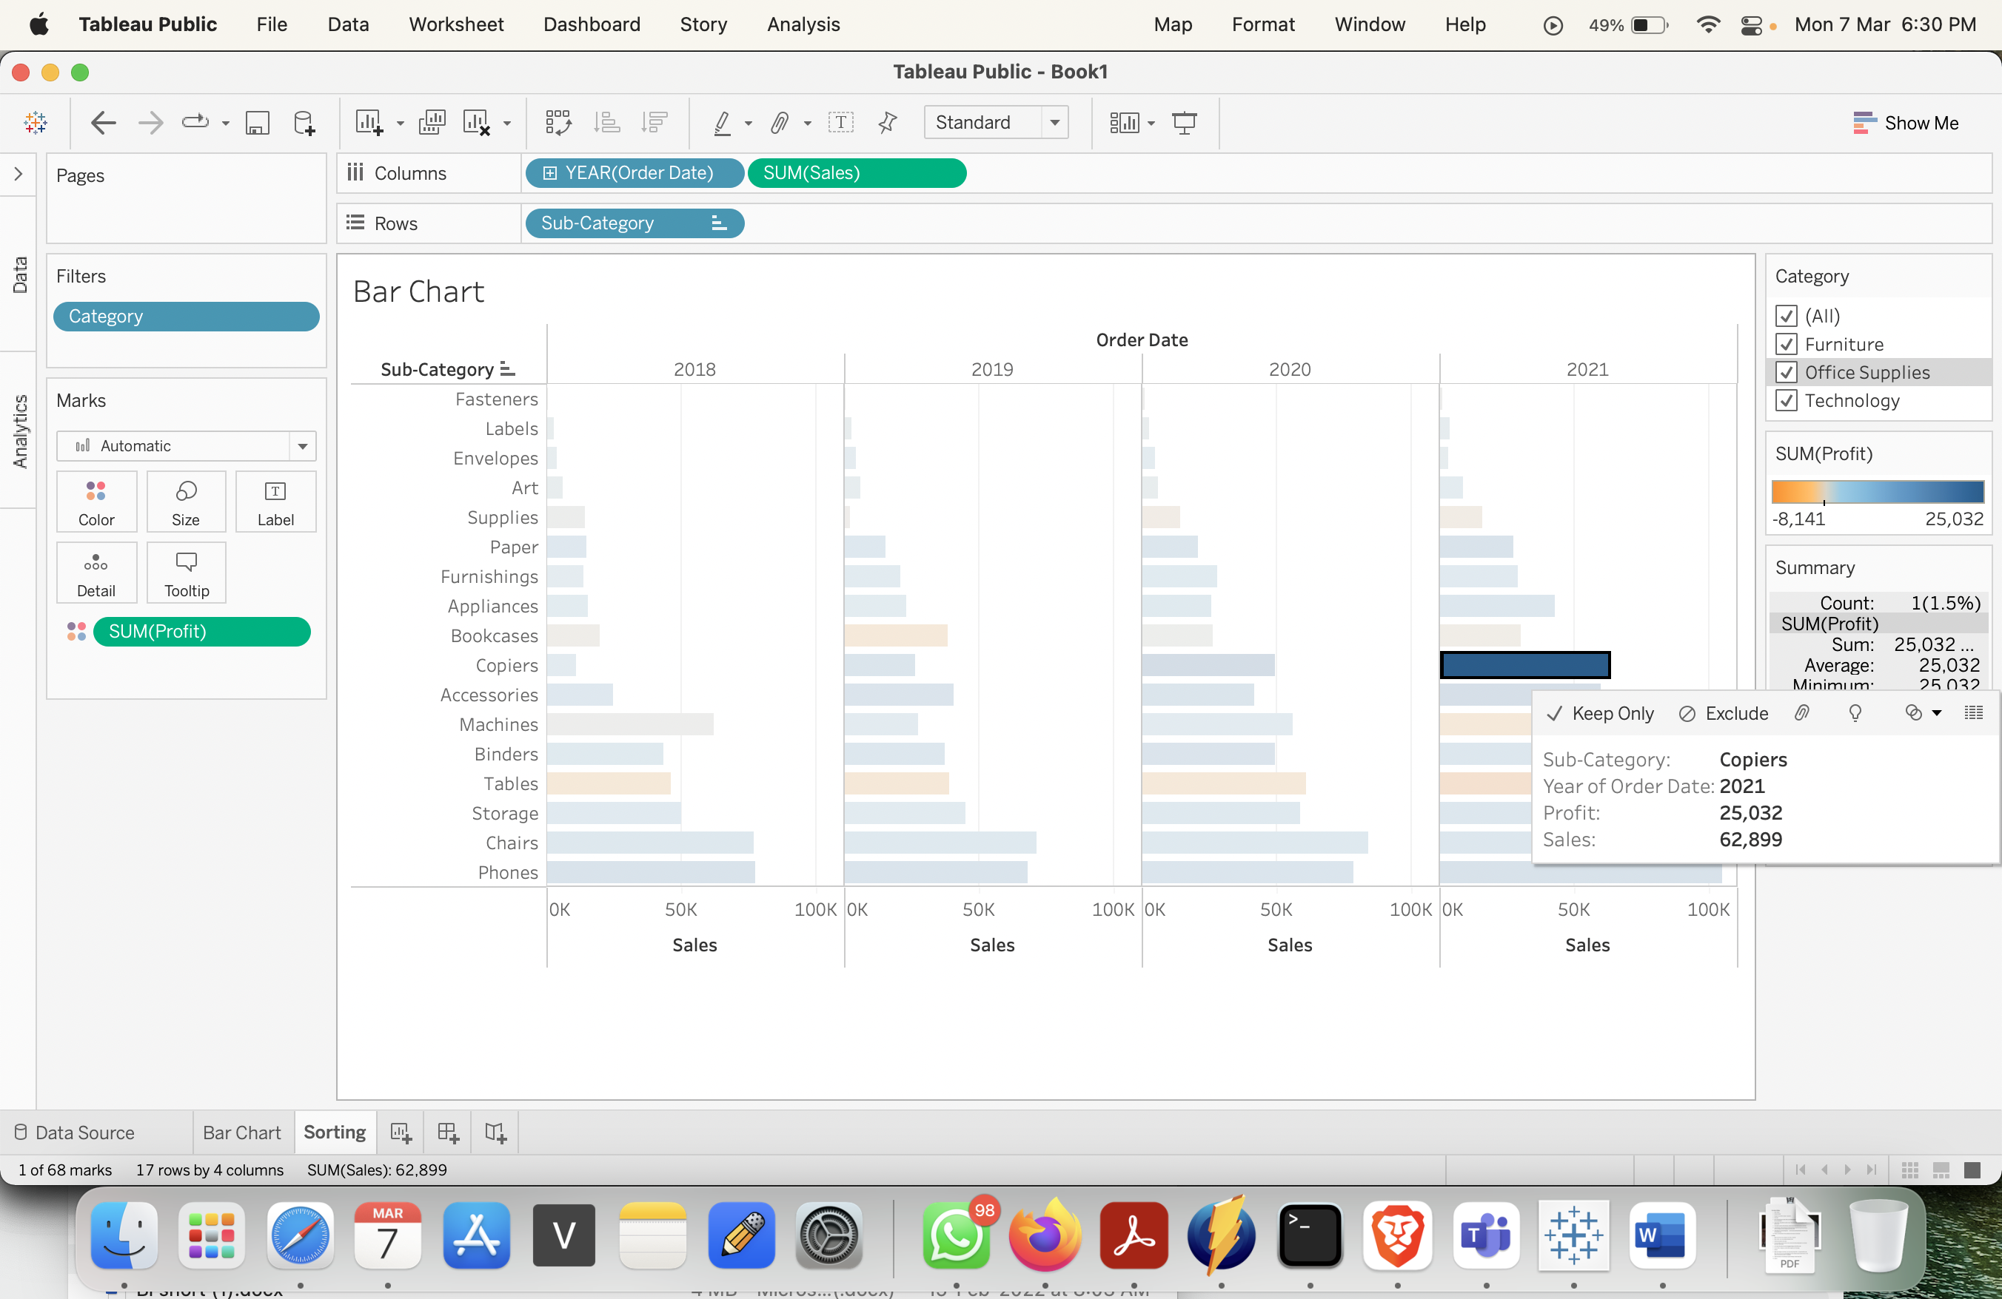

  
Although Phones Sales is High, the profit is low when compared to Copiers

# **Analysing Machines**

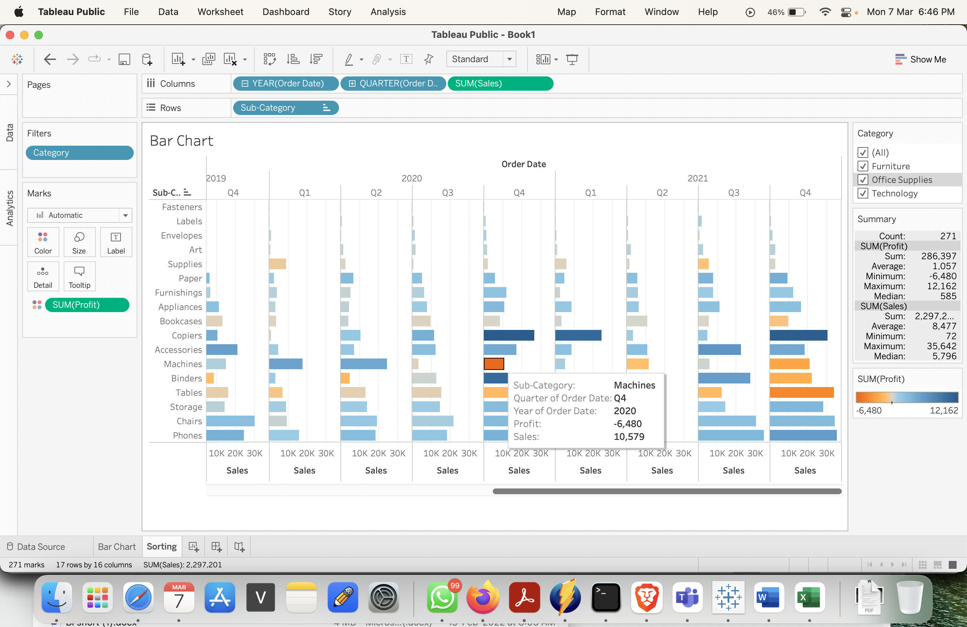

4th Quarter of 2020, Machines has faced a severe and huge loss when compared to anyother

# **Analysing Copiers in every Quarter**

Q4 of 2020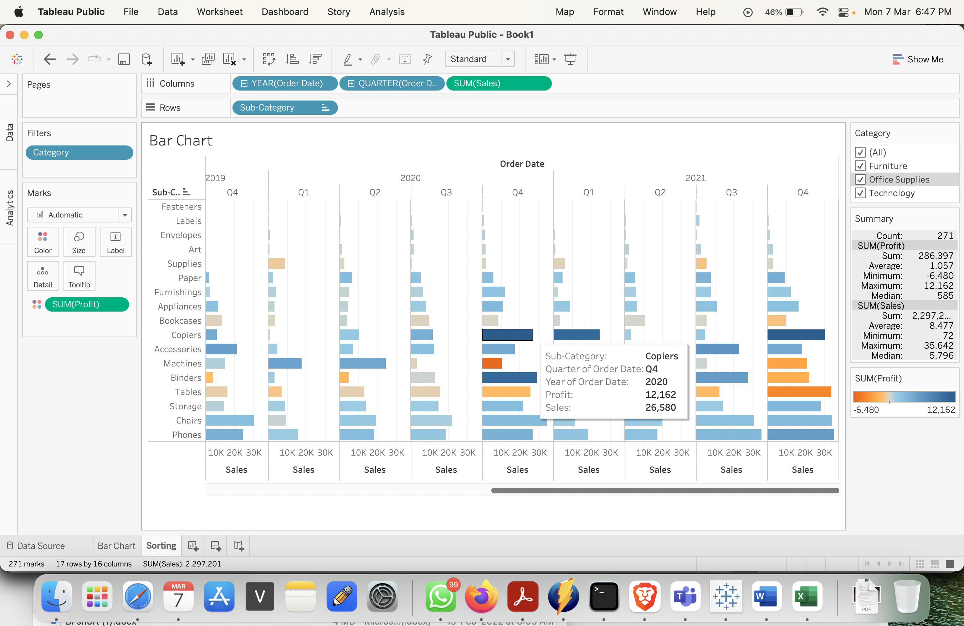

Q1 of 2021

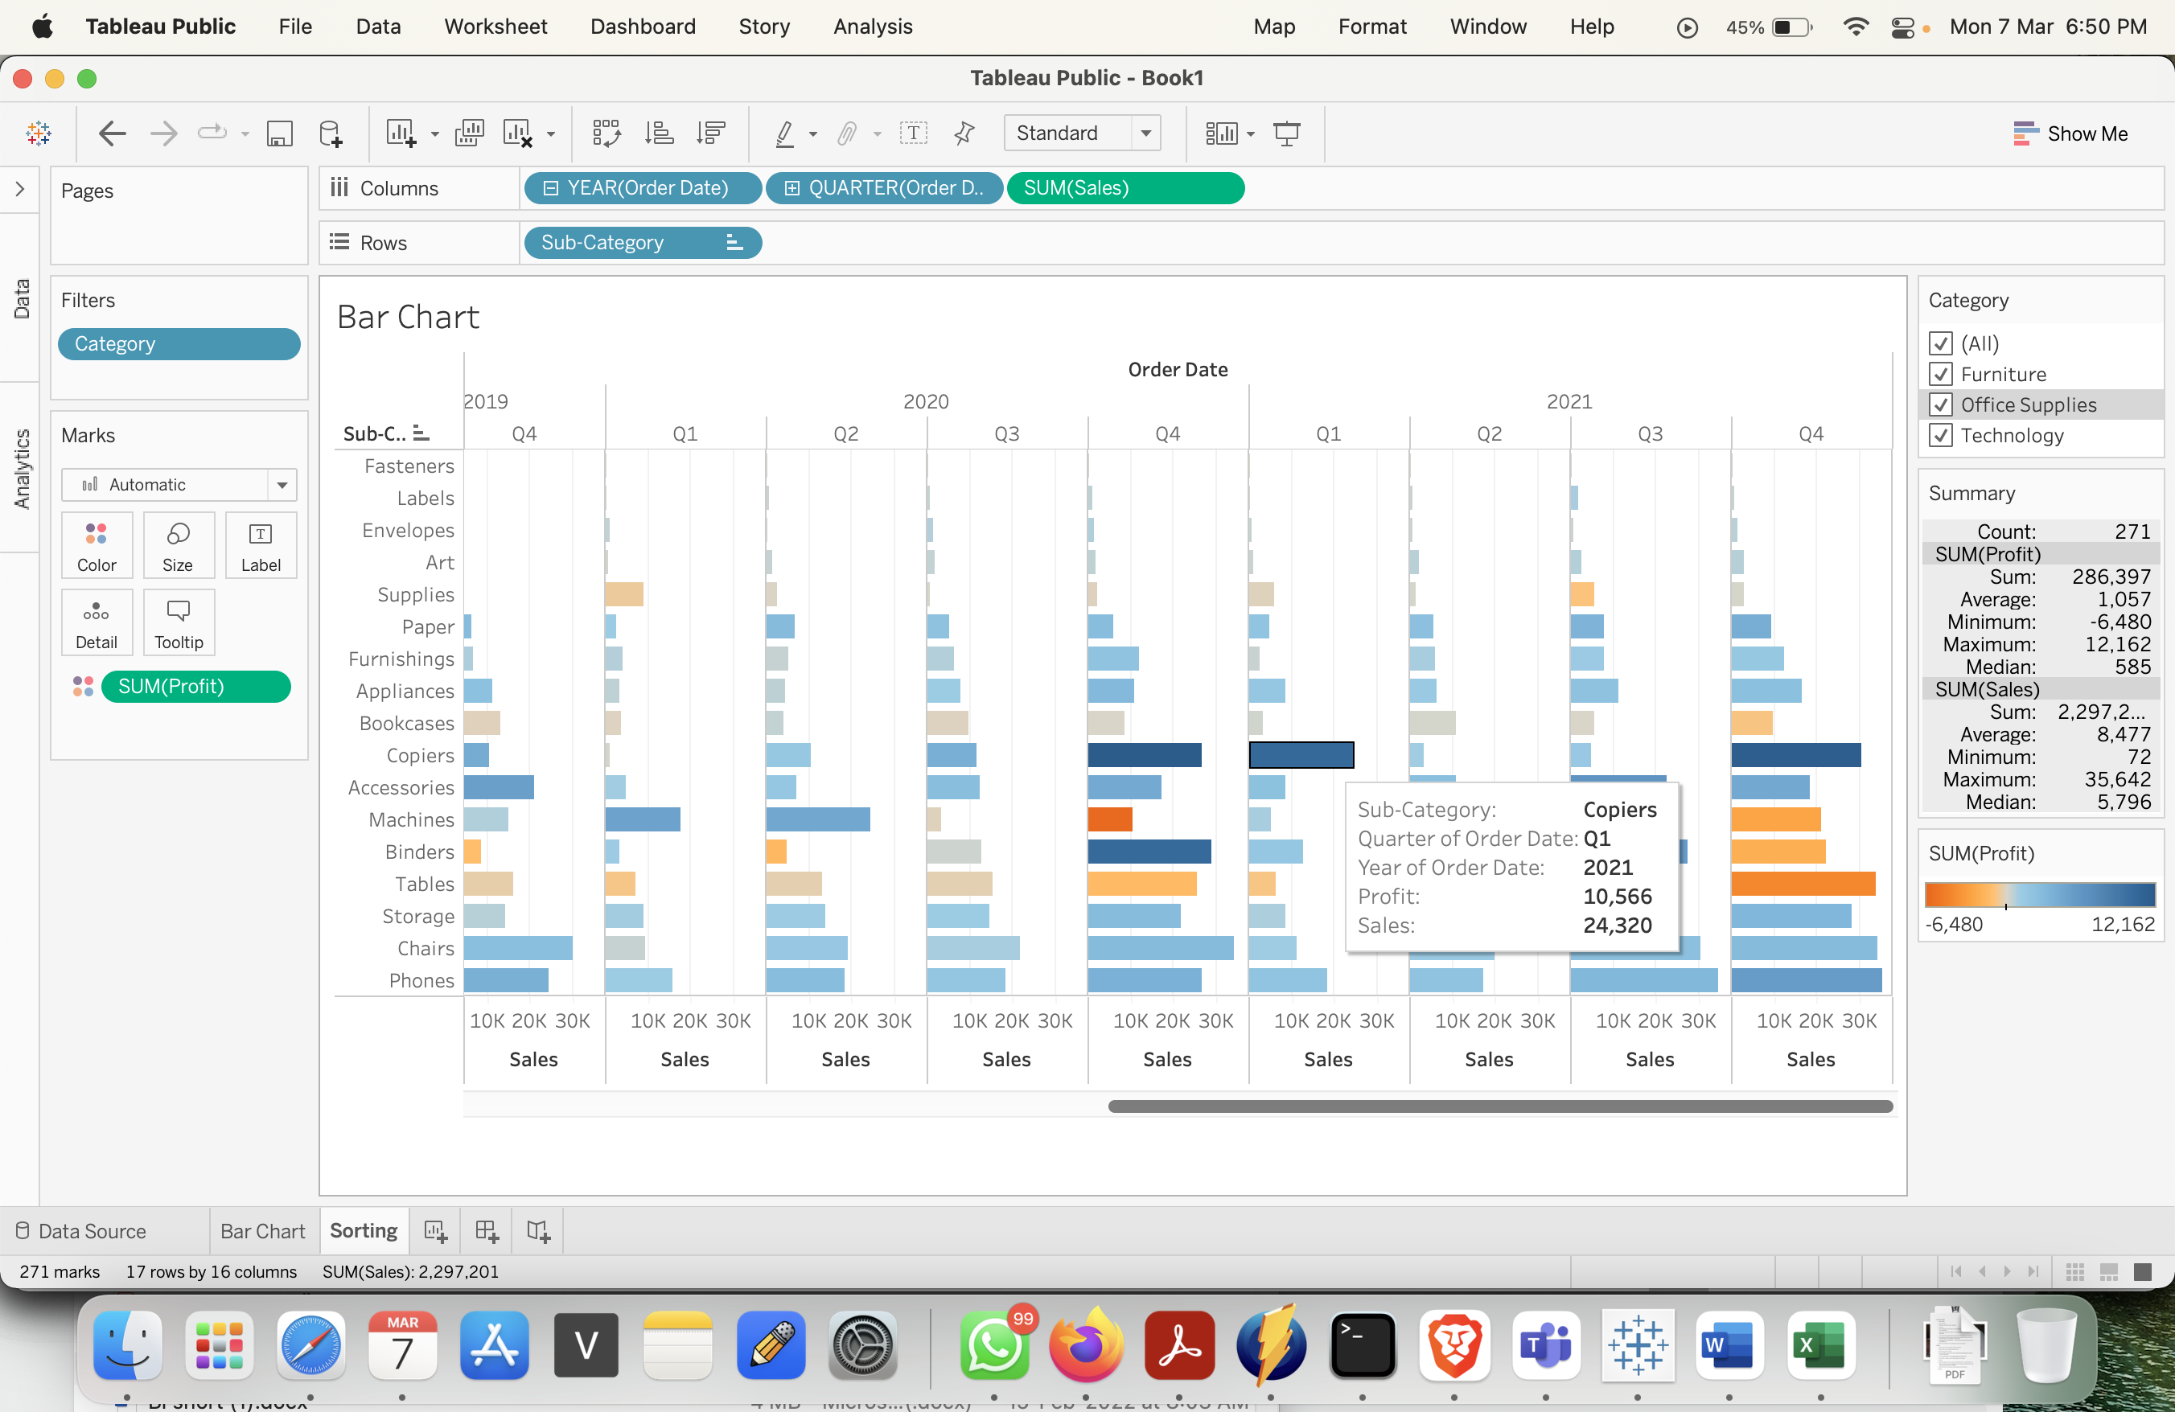

Q4 of 2021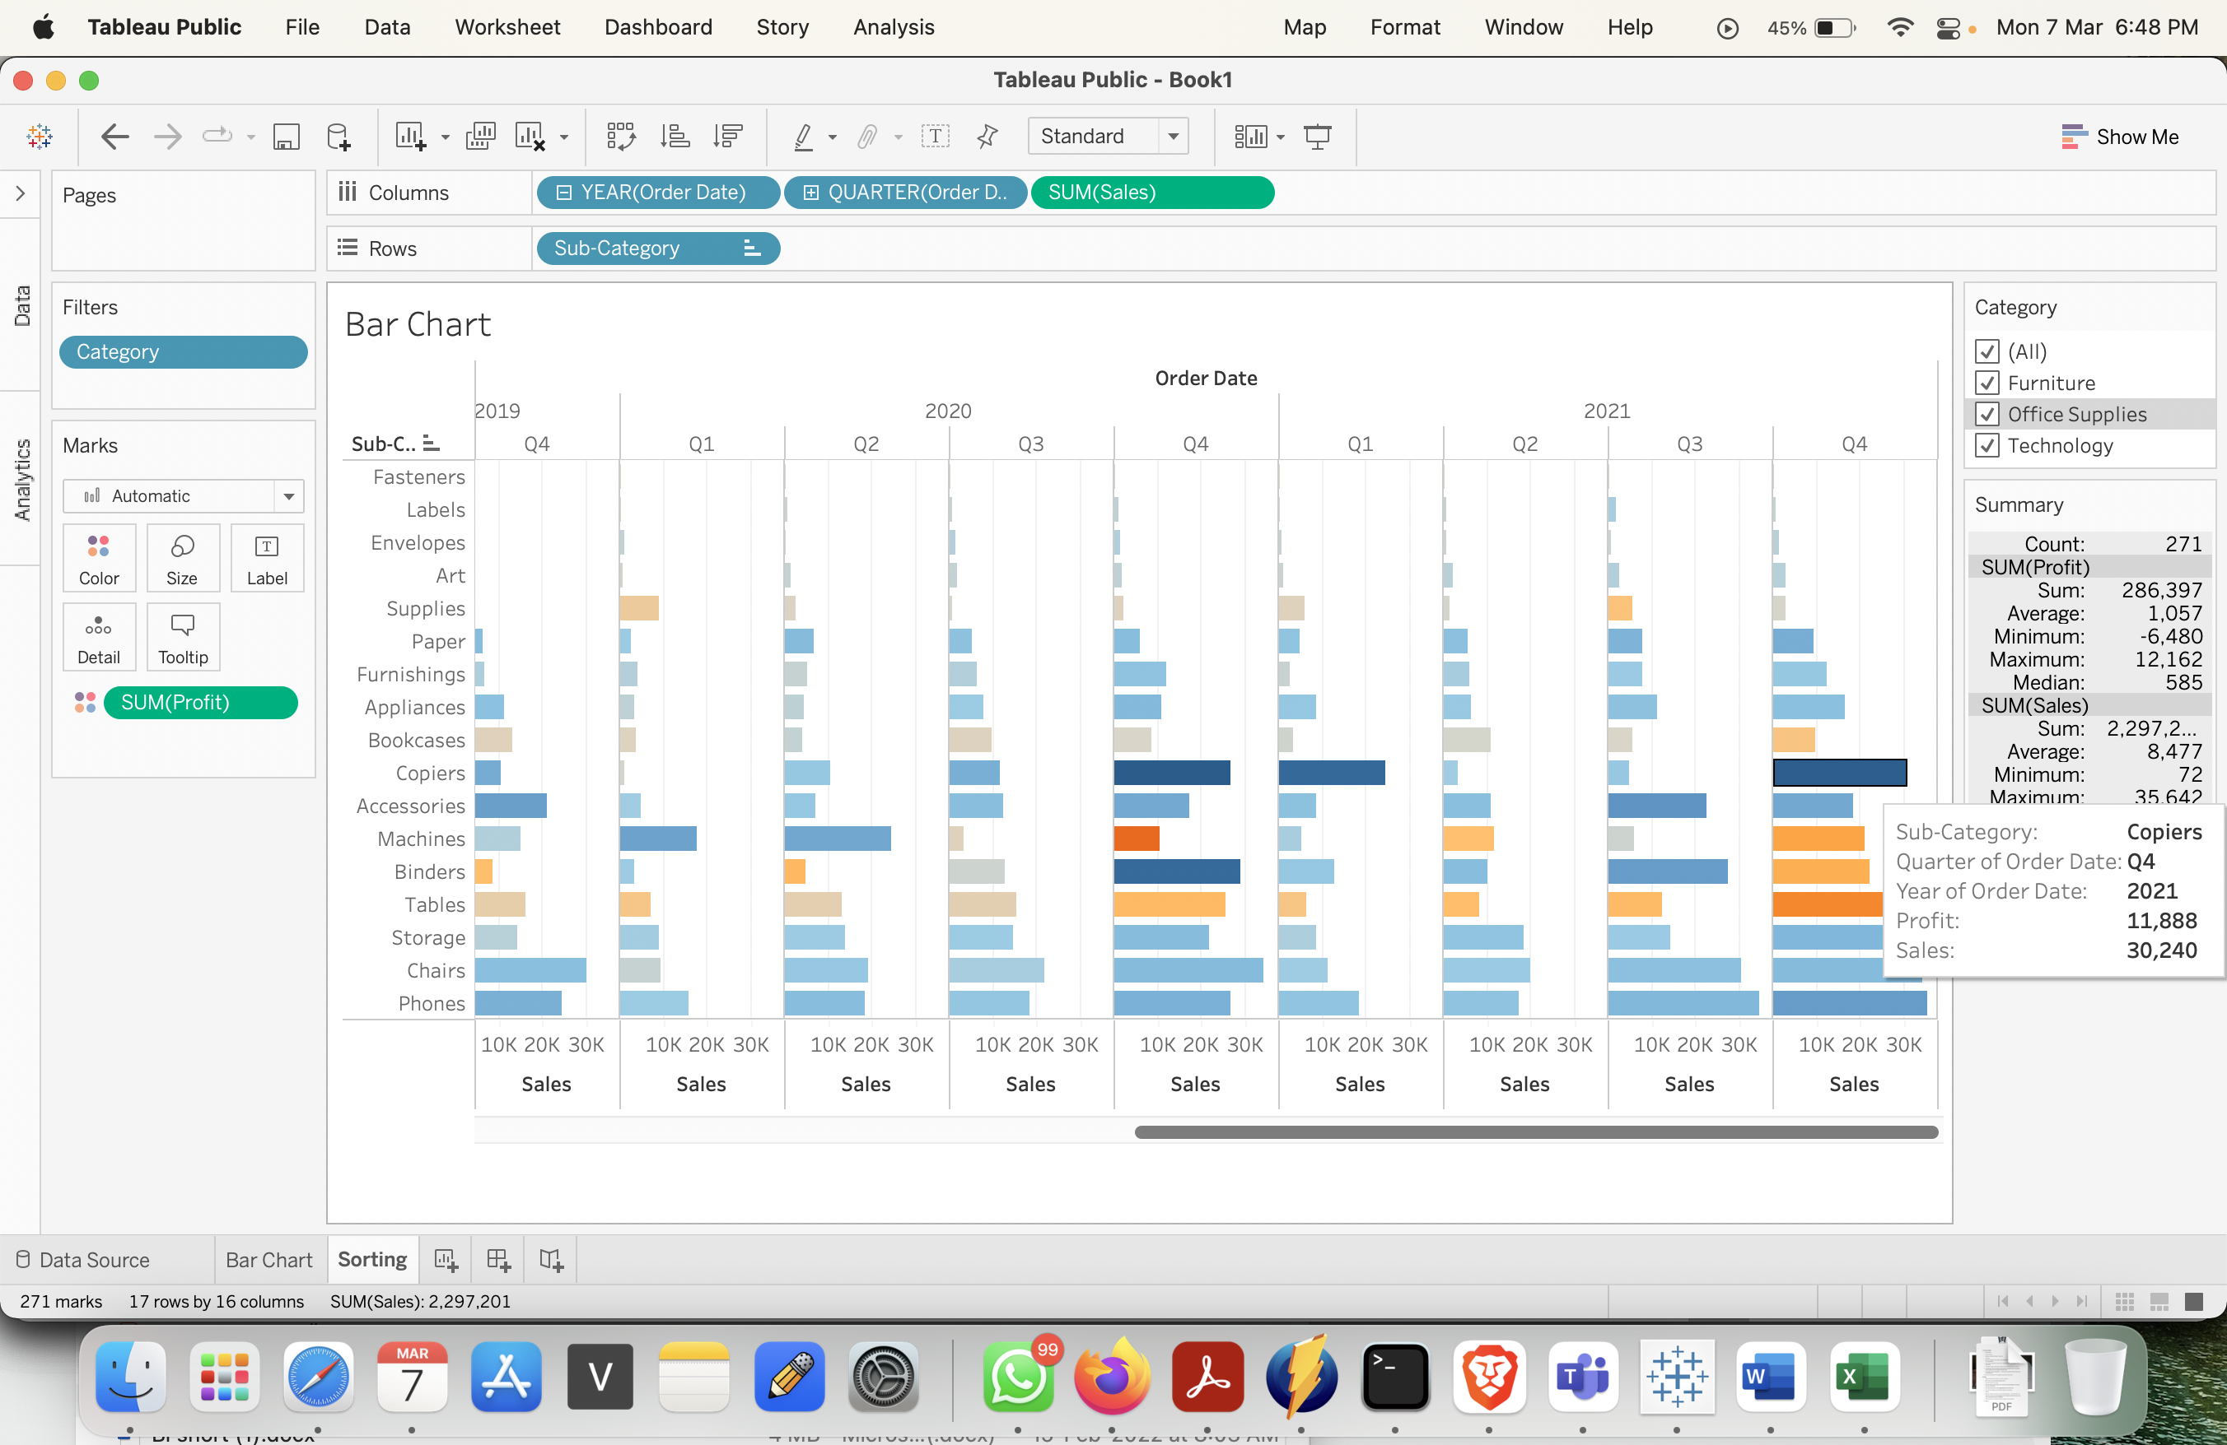

|  |  |  |
| --- | --- | --- |
|  | Sales | Profit |
| Copier (Q4 of 2020) | 26,580 | 12,162 |
| Copier (Q1 of 2021) | 24,320 | 10,566 |
| Copiers (Q4 of 2021) | 30,240 | 11,888 |

In Q4 of 2020 and 2021, Copier Profit hits the maximum.